Project Specifications
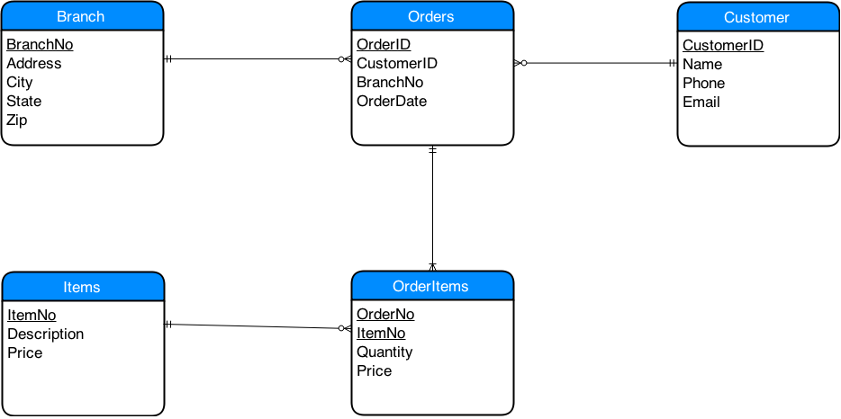
Using the Entity Relationship Diagram (ERD) above, create a web application using PHP Data Objects to input data and then create a report that displays the items ordered for a given order ID.
Ilinka Stojanov | Joshua Caperton | Brandon Nguyen | Sheldrick Eluett
 |  |  | 
Note: The web application must create the database and tables necessary to store the data.

Team Project Grading Rubric
Criteria | Excellent  5 points | Good  4 points | Fair  3 points | Poor  0 points
Specifications | The program works and meets all of the specifications. | The program works and meets most of the specifications. | The program works and meets some of the specifications. | The program does not work and meets none of the specifications.
Correctness | Program correctly solves problem in all cases, exceeds problem specifications, meets language feature requirements and generally makes the instructor think that you’re a really hoopy frood. | Program correctly solves problem in most cases, but may have minor problems in some instances. All language feature requirements are used and the program generally makes the instructor think that you know what you’re doing. | Program solves problem in some cases, but has one or more problems. It meets all language feature requirements, but makes the instructor wonder if you really know what’s going on. | Does not solve any problem.
Aesthetics | The Web pages have an exceptionally attractive and usable layout. It is easy to locate all important elements. White space, graphic elements and/or alignment are used effectively to organize material. | The Web pages have an attractive and usable layout. It is easy to locate all important elements. | The Web pages have a usable layout, but may appear busy or boring. It is easy to locate most of the important elements. | No web pages submitted
HTML & CSS | There are no HTML or CSS errors. | There are 1-3 HTML or CSS errors. | There are 4-6 HTML or CSS errors. | There are 7 or more HTML or CSS errors. No work submitted.
Participation | Consistently works toward team goals; is sensitive to feelings of others and values all  members. Encourages team action for change. | Usually works toward team goals and contributes. Is usually sensitive to the feelings of others. | Sometimes works toward team goals and contributes. Is not often sensitive to the feelings of others. | Never works toward group goals or contributes. Is not sensitive to the feelings of others.
CTS 2857C: Server-side Scripting
© 2015 - Professor George Cooke

